# Encoder Information

## **Renishaw Encoders**

### **Renishaw T16xx linear encoder**

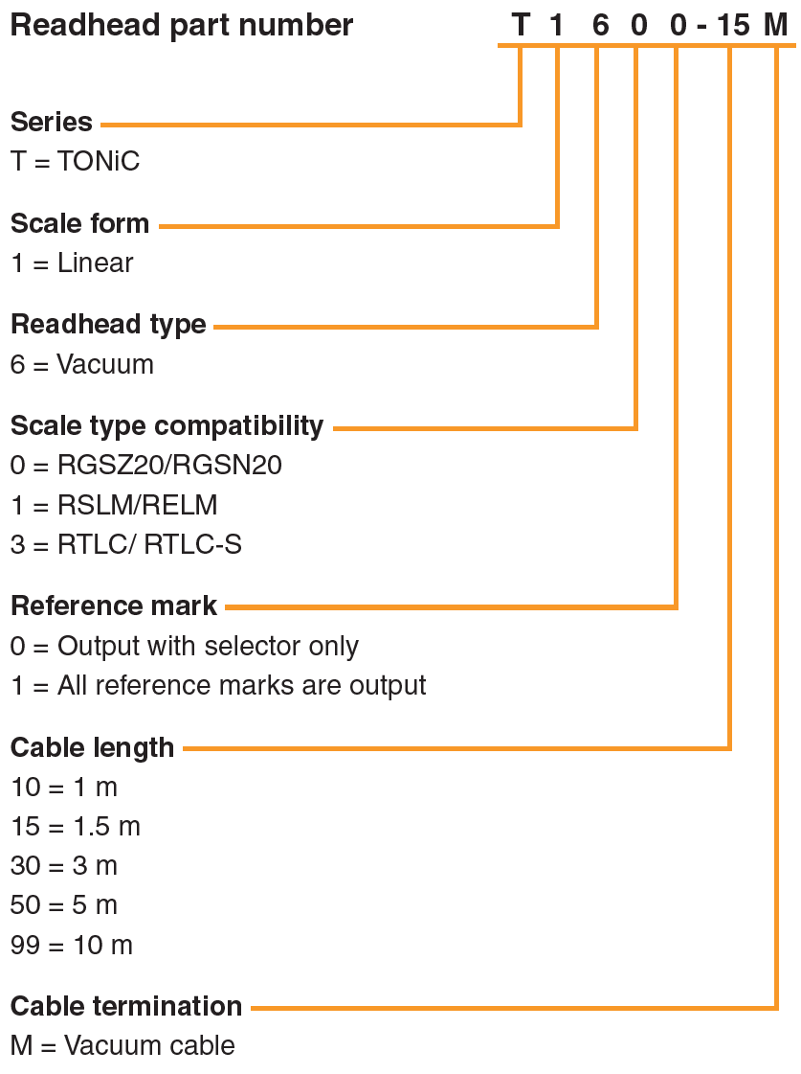

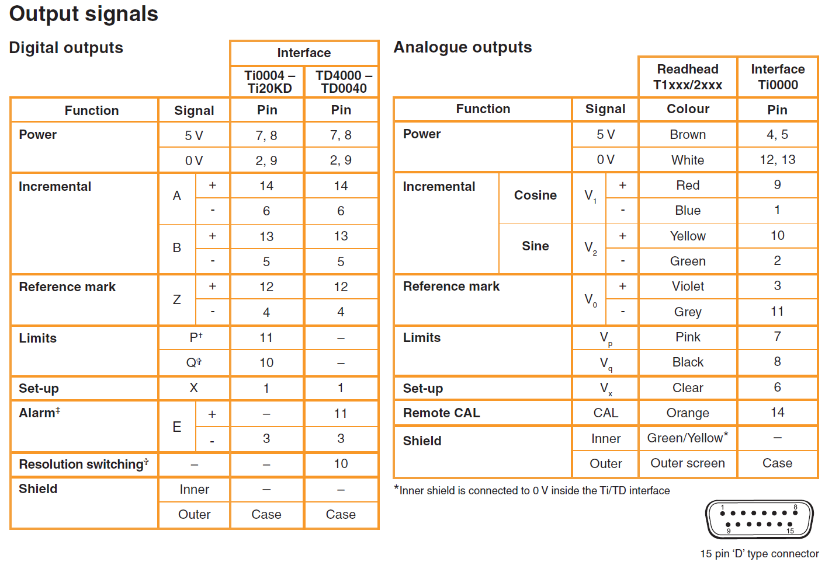

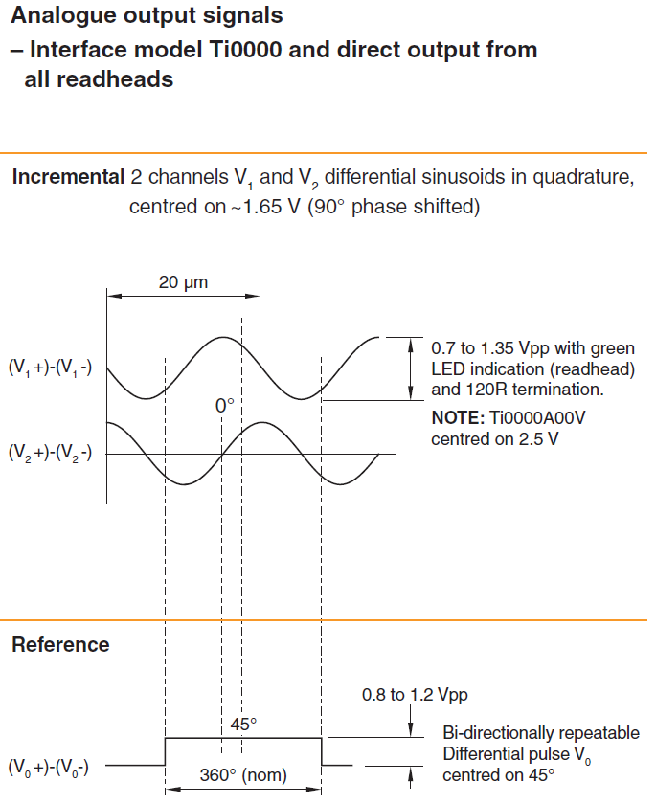

|  |  |
| --- | --- |
| Pin | Signal |
| 1 | Set-up X |
| 2 | GND |
| 3 | Alarm E- |
| 4 | Z- |
| 5 | B- |
| 6 | A- |
| 7 | VCC |
| 8 | VCC |
| 9 | GND |
| 10 | Limits Q |
| 11 | Limit P |
| 12 | Z+ |
| 13 | B+ |
| 14 | A+ |
| 15 |  |

### **Renishaw RESOLUTE absolute optical encoder**

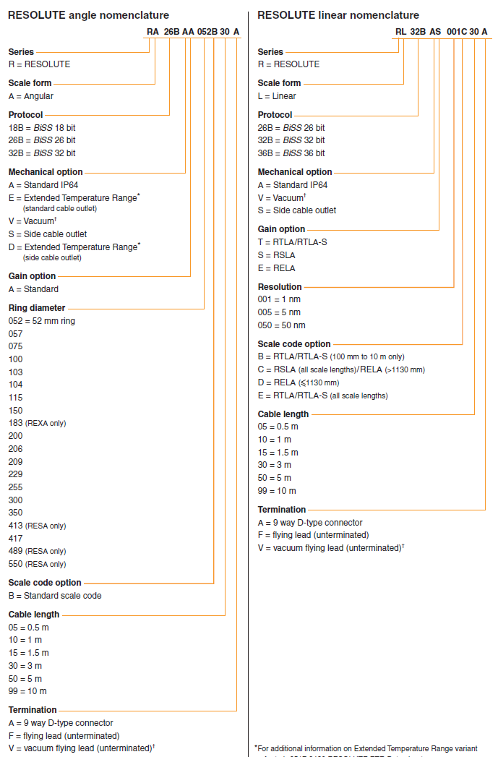

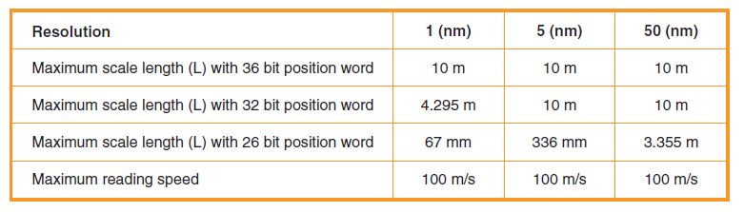

RESOLUTE with BiSS serial comms is available with the following resolution options:

18 bit (262 144 counts per revolution, ≈ 4.94 arc second)

26 bit (67 108 864 counts per revolution, ≈ 0.019 arc second)

32 bit (4 294 967 296 counts per revolution, ≈ 0.00030 arc second)

Note that 32-bit resolution is below the noise floor of the RESOLUTE encoder.

**RL32BAT001B15A**: Linear BiSS32-bit Standard IP64 RTLA/TRLA-S 1nm (resolution) encoder with DB-9 connector.

## **AFE board**

In digital Pizzabox, AFE boards are used to interface with digital encoders and PMACs.

### **AFE input**

The AFE input signals come from digital encoders.

|  |  |
| --- | --- |
| Pin | Signal |
| 1 | ST_PLS- |
| 2 | GND |
| 3 | ST_DIR- |
| 4 | Z- |
| 5 | B- |
| 6 | A- |
| 7 | VCC |
| 8 | VCC |
| 9 | GND |
| 10 | ST_PLS+ |
| 11 | ST_DIR+ |
| 12 | Z+ |
| 13 | B+ |
| 14 | A+ |
| 15 | NC |

### **AFE output**

AFE output signals goes to PMACs.

|  |  |
| --- | --- |
| Pin | Signal |
| 1 | A+ |
| 2 | A- |
| 3 | B+ |
| 4 | B- |
| 5 | Z+ |
| 6 | Z- |
| 7 | VCC |
| 8 | GND |
| 9 | ST_DIR+ |
| 10 | ST_DIR- |
| 11 | ST_PLS+ |
| 12 | ST_PLS- |
| 13 |  |
| 14 | VCC |
| 15 | GND |